

MARMARA UNIVERSITY
FACULTY OF ENGINEERING

PHYS 1104
PHYSICS LABORATORY II
—————————————————————————————————————————
Equipotential and Electric Field Lines
—————————————————————————————————————————
Section: 12

Group: 5

Instructure: Equipotential and Electric Field Lines Date: 09/05/2024 8:59 am

 | Department | Student ID Number | Name & Surname
1 | Computer Engineering
2 | Computer Engineering
3 | Computer Engineering

1. Table of Contents

1. Table of Contents 2
2. Purpose 3
3. Theory 3
4. Experimental Setup 3
4.1. List Of Materials 4
4.2. Procedure 4
5. Calculations and Results 5
Part 1 5
6. Discussion and Conclusion 8
7. References 9
8. Appendix 10
Experiment Sheet 10

2. Purpose
Mapping Equipotential and Electric Field Lines in a System of Oppositely Charged Conducting Rings
The purpose of this experiment is to investigate and map the equipotential lines and electric field lines between two oppositely charged conducting rings. By using a setup involving silver conductive ink electrodes on conductive paper, connected to a power supply, this study aims to:
1.Determine equipotential points on the conductive paper and map equipotential lines by measuring potential differences.
2.Understand the relationship between equipotential lines and electric field lines in a two-dimensional electric field configuration.
3.Investigate the effects of the conducting rings on the distribution of equipotential lines and electric field lines, particularly near the rings' surfaces.
4.Verify experimentally that the surface of the conducting rings acts as an equipotential surface.

Through this experimental investigation, we aim to deepen our understanding of electrostatic principles and the behavior of electric fields in the vicinity of conducting structures, contributing to the knowledge of fundamental electrostatic concepts and their practical applications.

3. Theory
Electric Fields: Electric fields (𝐸⃗E) are vector fields that describe the force experienced by a charged particle at any point in space. They arise from the presence of electric charges and exert forces on other charges within their vicinity. The electric field at a point is defined as the force per unit charge experienced by a positive test charge placed at that point.
For a system of oppositely charged conducting rings, the electric field lines originate from positive charges and terminate on negative charges. In this experiment, two oppositely charged rings connected to a power supply create an electric field between them. The direction of the electric field lines depends on the relative magnitudes and positions of the charges.
Equipotential Lines: Equipotential lines are imaginary lines that connect points in a field where the electric potential is the same. The electric potential (𝑉V) at a point is the electric potential energy per unit charge at that point. In a uniform electric field, equipotential lines are perpendicular to electric field lines
Relationship between Electric Fields and Equipotential Lines:
- Electric field lines and equipotential lines are always perpendicular to each other. This relationship ensures that work done in moving a charge along an equipotential line is zero, as no change in potential occurs along these lines.
- Equipotential lines closer together indicate a stronger electric field, as the change in potential per unit distance is higher.
Behavior near Conductors:
- Inside a conductor, the electric field is zero in electrostatic equilibrium. Charges redistribute themselves to cancel out any external electric fields within the conductor.
- On the surface of a conductor, the electric field is perpendicular to the surface and strongest at points with the highest curvature (sharp edges or points).
Experimental Setup and Objectives: In this experiment, the setup involves placing conductive rings on a conductive paper connected to a power supply to create a controlled electric field. By measuring potential differences between points on the paper, equipotential lines are mapped. The behavior of equipotential lines and electric field lines near the conducting rings provides insights into the distribution of electric fields and potentials in complex charge configurations.
This experiment helps illustrate fundamental concepts in electrostatics, such as electric fields, potentials, conductors’ behavior, and the relationship between equipotential and electric field lines. The data collected and analyzed from this experiment offer a practical understanding of these concepts in real-world electrical systems and devices.

4. Experimental Setup

4.1 Equipment List
1. Black Conductive Paper
2. DC Power Supply
3. Multimeter (Voltmeter)
4. Graph Paper
5. Corkboard
6. Pushpins
7. Connecting Wires
8. Standard Power Cable
9. Student and Teacher Manuals

4.2 Procedure
Tabii, işte metnin İngilizce çevirisi:

1. Draw the plan and drawing of two conductive rings (charge paths) on a graph paper.
1.1. These conductive paths (charge distributions) can be in any two-dimensional shape such as circles or dots, hence they will be referred to as conductive ink electrodes.
1.2. Draw the two rings symmetrically on the paper along the x-axis and y-axis.

2. Mount the conductive paper (carbon paper) onto a cork board using metal pushpins, one at each corner.
Figure-14: Attaching pushpin, electrode, wire, and paper to the cork board.

3. Assemble the circuit shown in Figure-(13).
3.1. Use connection wires to connect the conductive electrodes (two ink electrodes on carbon paper) to a power source. The electrodes can be in any two-dimensional shape such as a point, straight line, or circle.
3.2. Place the terminal of the connection wire onto the conductive ring electrode and then secure the terminal and electrode to the cork board with a pushpin (see Figure-14).
3.3. The pushpin is only used to hold the connection wire to the electrode and does not function as a conductor.

4. Check the conductivity of the rings (electrodes). For this process:
4.1. Connect one terminal of a voltmeter probe to a point near a conductive ring (electrode).
4.2. Touch the second probe of the voltmeter to several different points on the same electrode.
4.3. If the ring is correctly drawn, the maximum potential difference between any two points on the same electrode should not exceed 1% of the potential difference between the two electrodes (i.e., the voltage applied by the power source).

5. When voltage is applied between two metal electrodes, a two-dimensional electric field is created.
5.1. Set the output voltage of the power supply to 5-6 volts and turn it on.
5.2. When the ground terminal of the voltmeter is connected to the negative electrode and the positive probe is touched to the other, the voltmeter reads the voltage applied by the power supply.
5.3. To draw equipotential lines, the ground probe of the voltmeter (one end) touches the negative electrode, establishing the zero potential reference.
5.4. The second voltmeter probe measures the potential at any point on the carbon paper by touching it.

6. Now, you are ready to select six reference points along the x-axis of the paper ( , , , , , and ).
6.1. Ensure these points are distributed symmetrically around the origin.
6.2. Touch a probe to one of these points and then measure and record its potential relative to the reference electrode.
. . . . .
6.3. To map equipotential lines, move the probe while keeping the voltmeter reading constant.
6.4. Mark this point on the paper with a soft pencil.
6.5. Continue moving the probe but only in a direction that keeps the voltmeter reading constant.
. . . . .
6.6. Find ten equipotential points, five above and five below.
6.7. Repeat the experiment for the six previously chosen reference points.
6.8. Plot your points on a graph paper representing the carbon paper.

7. Draw equipotential (constant voltage) lines for each reference point by connecting the equipotential points with a smooth curve.

8. Considering electric field lines are perpendicular to equipotential lines, draw electric field lines in the region between the two charged rings.

9. Define equipotential lines. How are electric field lines drawn relative to equipotential lines?

10. Will the electric field always be zero at any point where the electric potential is zero? Why or why not?

11. Will the electric potential always be zero at any point where the electric field is zero?

12. Investigate equipotential points for a ring quarter placed using carbon paper at three reference points ( , , and ).
12.1. Repeat the experiment to find these new equipotential points and plot them on a second graph paper.

12.2. How do the equipotential (constant voltage) lines change in the presence of the conductive ring?
12.3. Also, draw the new electric field lines.

12.4. What is true about the electric field just outside the surface of a conductor?
12.5. Use the voltmeter probe to confirm that the surface of the conductive ring is indeed an equipotential surface.

5. Calculations and Results

5.1 Tables
Table 1: Left side of paper
The highest value is the volt value. The coordinates below the volt values ​​are the points where these volt values ​​are measured.

V | 0.27 | 0.30 | 0.32 | 0.33 | 0.34 | 0.36 | 0.37 | 0.38
 | 3,10 | 4,10 | 6,10 | 8,10 | 9,10 | 10,10 | 12,10 | 13,10
 | 2,13 | 4,11 | 6,11 | 8,11 | 9,11 | 10,11 | 12,11 | 13,11
 | 2,12 | 4,12 | 6,12 | 7,12 | 9,12 | 9,12 | 11,12 | 12,12
 | 1,14 | 3,13 | 5,13 | 7,13 | 7,13 | 9,13 | 11,14 | 12,13
 | 2,11 | 2,14 | 4,14 | 6,14 | 7,14 | 8,15 | 10,15 | 12,14
 | 2,8 | 4,9 | 6,9 | 8,9 | 9,9 | 10,9 | 12,9 | 13,9
 | 2,7 | 4,8 | 6,8 | 7,8 | 8,8 | 10,8 | 12,8 | 12,8
 | 1,6 | 3,7 | 5,6 | 7,7 | 8,7 | 9,7 | 11,7 | 12,7
 | 3,9 | 2,6 | 5,7 | 6,6 | 7,6 | 9,6 | 10,6 | 11,6

5.1 Tables
Table 1: Right side of paper
The highest value is the volt value. The coordinates below the volt values ​​are the points where these volt values ​​are measured.

V | 0.42 | 0.44 | 0.46 | 0.56 | 0.60
 | 16,10 | 18,10 | 20,10 | 25,10 | 26,10
 | 16,11 | 18,11 | 20,11 | 25,11 | 26,11
 | 17,12 | 18,13 | 21,12 | 25,12 | 26,12
 | 17,13 | 19,14 | 21,13 | 25,13 | 27,13
 | 18,14 | 19,15 | 22,14 | 26,14 | 27,14
 | 16,9 | 18,9 | 20,9 | 25,9 | 26,9
 | 16,8 | 18,8 | 20,8 | 25,8 | 26,8
 | 17,7 | 19,7 | 21,7 | 26,7 | 27,7
 | 17,6 | 19,6 | 22,6 | 27,6 | 27,6

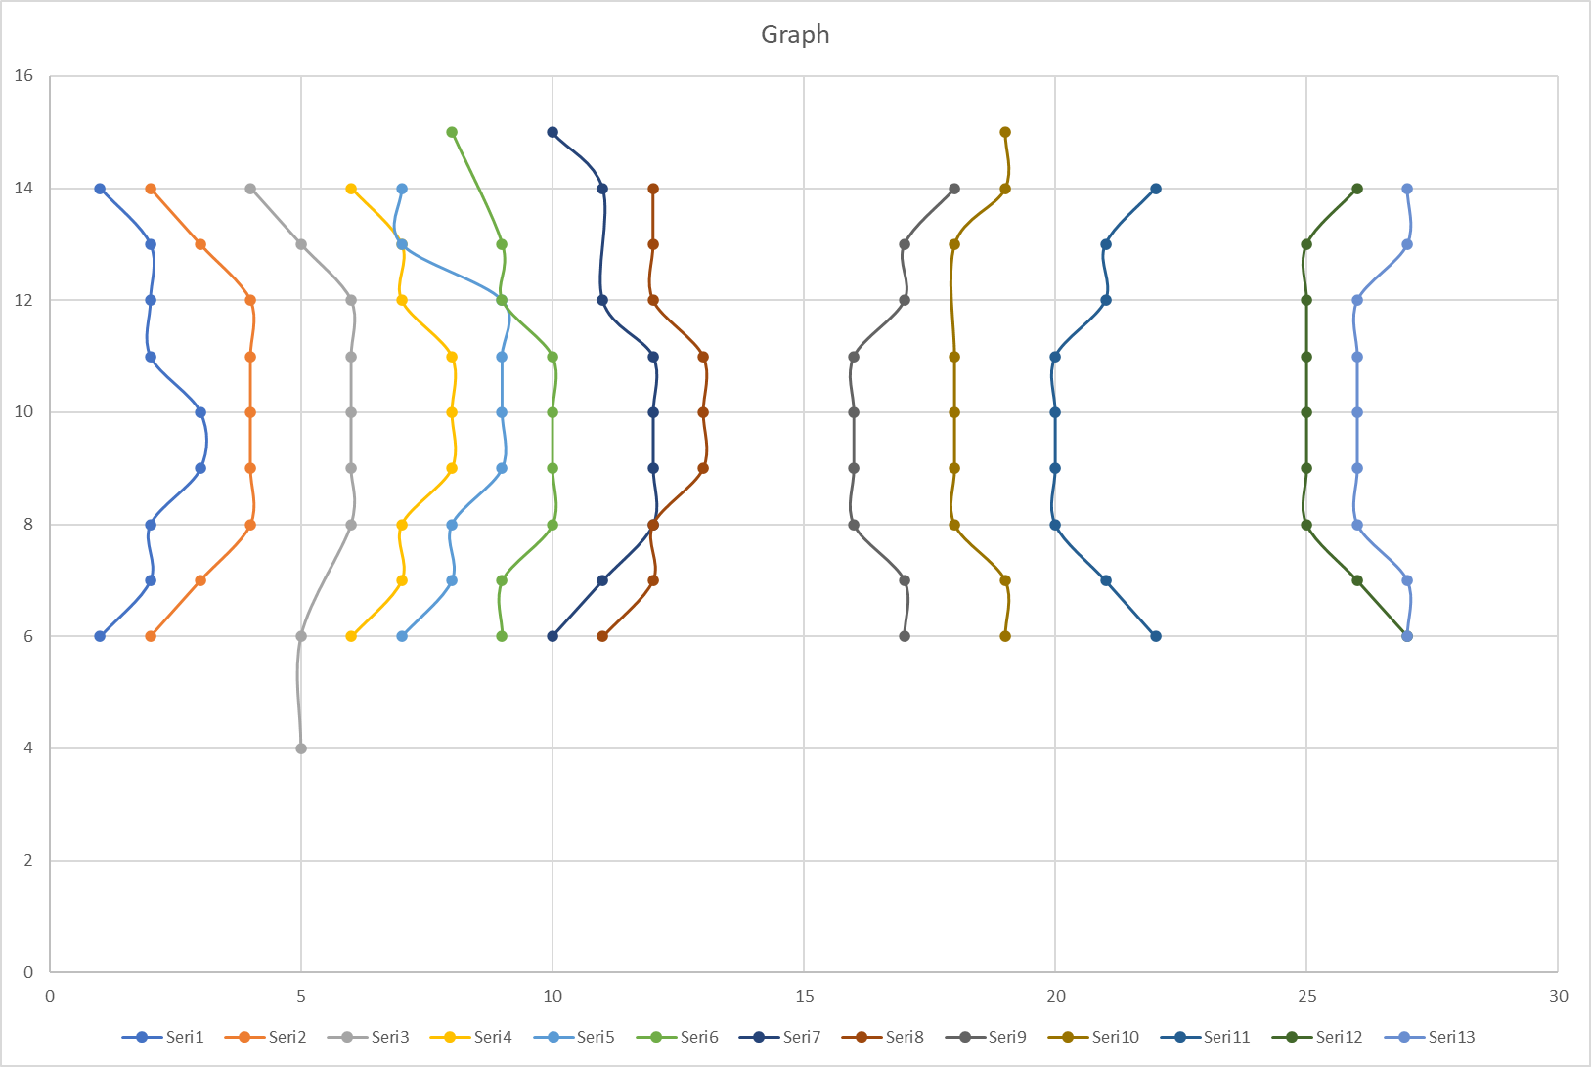

6. Discussion and Conclusion
In this experiment, we explored the behavior of electric fields and equipotential lines in a system of oppositely charged conducting rings. Through a systematic approach involving mapping equipotential lines and understanding the relationship with electric field lines, several key observations and conclusions were drawn.
Equipotential Lines and Electric Field Distribution:
- Equipotential lines were successfully mapped on the conductive paper, revealing regions of constant electric potential between the charged rings.
- The arrangement of equipotential lines provided insights into the distribution of the electric field in the region between the conducting rings.
Relationship Between Equipotential and Electric Field Lines:
- As expected, equipotential lines were found to be perpendicular to electric field lines. This relationship is fundamental in understanding the interplay between electric potentials and fields.
Effects of Conducting Rings:
- Near the conducting rings, significant changes in equipotential lines and electric field lines were observed. The presence of the rings altered the electric field distribution and potential gradients in their vicinity.

Verification of Conducting Ring as an Equipotential Surface:
- By measuring equipotential points along the surface of the conducting ring, we confirmed that the ring's surface acts as an equipotential surface. This aligns with theoretical expectations for conductors in electrostatic equilibrium.
Insights into Electric Field Behavior:
- The experiment highlighted how electric field lines originate from positive charges and terminate on negative charges, illustrating the directionality of electric fields in the setup.
- The behavior of electric fields near conductors, including the zero electric field within conductors and perpendicularity at surfaces, was observed and verified.
Practical and Theoretical Implications:
- The results of this experiment contribute to a deeper understanding of electrostatic principles and their practical applications in engineering and physics.
- The concepts of equipotential lines, electric field lines, and their relationship provide a framework for analyzing and designing electrical systems.
In conclusion, this experiment not only demonstrated fundamental principles of electrostatics but also underscored the importance of mapping equipotential and electric field lines in understanding the behavior of electric fields in complex charge distributions. Future experiments and applications can build upon these findings to further explore electrostatic phenomena and their applications in diverse fields.

7. References
-https://canvas.instructure.com/files/249546881/download?download_frd=1
-https://canvas.instructure.com/files/245848695/download?download_frd=1

8. Appendix

Experiment Sheets

